Name: Phani Kumar
Batch: June 01 2022
Tutor: Raham Shaik
Project Name: Webservers Installation
Apache Installation on Ubuntu Machine:
- Created an EC2 Instance with Ubuntu image and switch to root user using sudo su – command.
- Updated the instance by using the (apt-get update -y) command
- Installed apache Package by using the (apt install apache2 -y) command.
- Check the apache Version by running (apache2 -version)
- 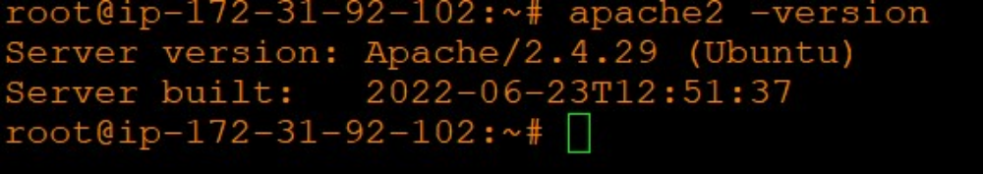
- I have restarted the Apache2 by running the ( systemctl restart apache2.service ) command
- I have checked the Apache2 Status by running the ( systemctl status apache2.service )
- 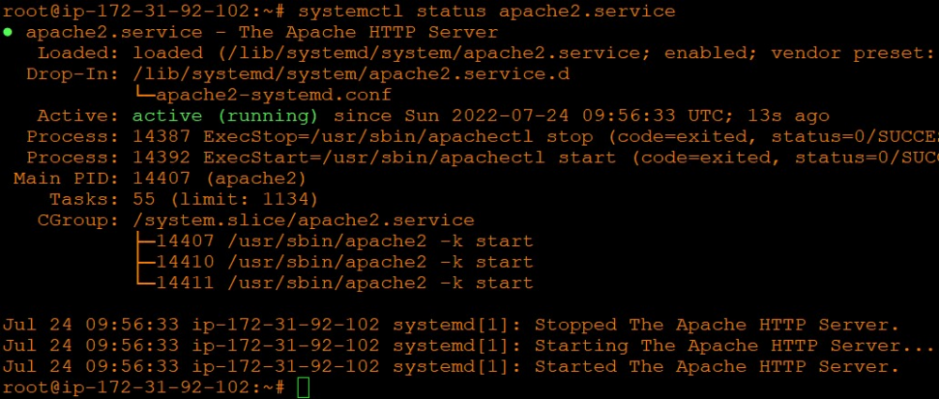
- Go to cd /var/www/html directory
- 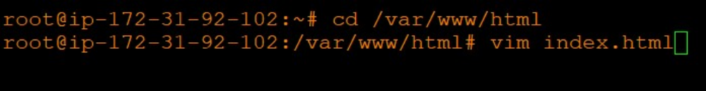

- Create index.html file and edit by using vim index.html and enter below content and then save and exit (:wq)
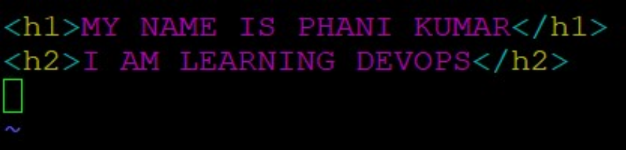
- Go to browser and paste public ip:80 then you will get below information what you have entered in index.html
- 

NGINX ON AMAZON LINUX2:

- Create an EC2 instance on Linux2 Image and switch to root user by using sudo -i
- Update the instance by using the command sudo yum update -y
- Then install Extra packages for enterprise Linux (EPEL) by following command
sudo amazon-linux-extras install epel -y
- Then install NGNIX by using following command ( yum install nginx -y )
- Then go to yum.repos.d directory by using cd /etc/yum.repos.d
- 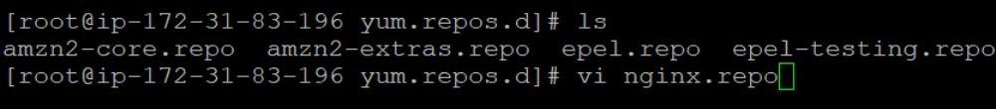
- Then go to nginx.repo and wrote some script by using ( vi nginx.repo ) command
- 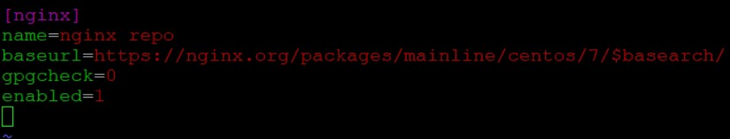
- Restart the ngnix by running the ( systemctl restart nginx.service ) command
- Checked ngnix status by running the ( systemctl status nginx.service ) command
- Public IP is configured with port 80 by running the ( curl localhost:80 ) command.
- 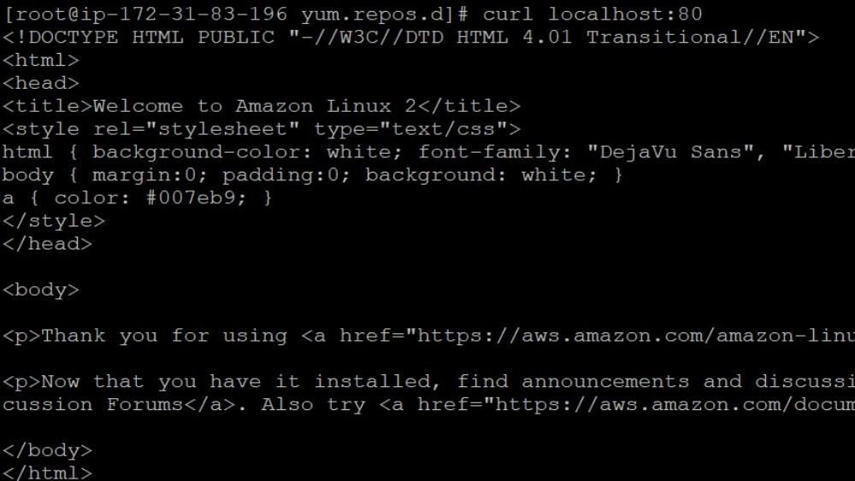
- Taken Instance Public IP address with port 80 and pasted it on the browser to check Nginx webserver is working or not.
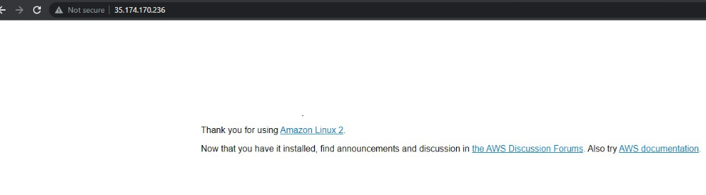
IIS INSTALLATION:
- Taken Windows 2012 Server and launched instances.
- Taken Ports RDP, HTTP & HTTPS anywhere
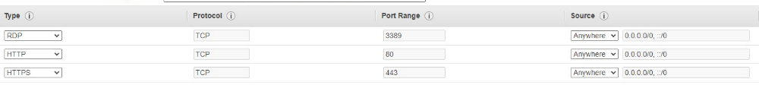

- Connected through RDP Client by downloading it and decrypting the password.
- Connected to the server through RDP Client
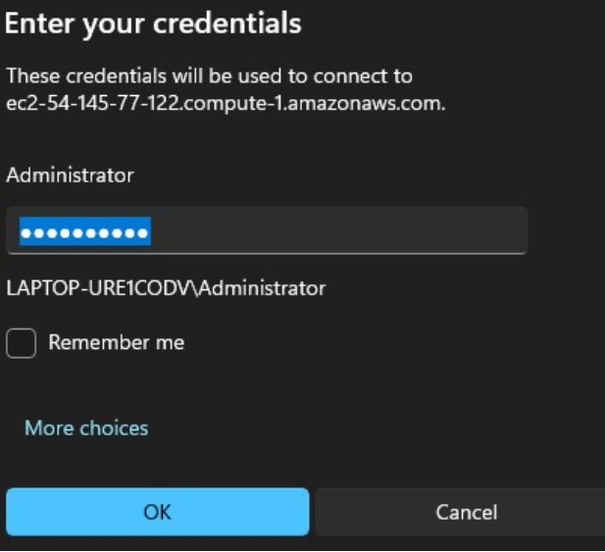.
- Opened Server Manager.

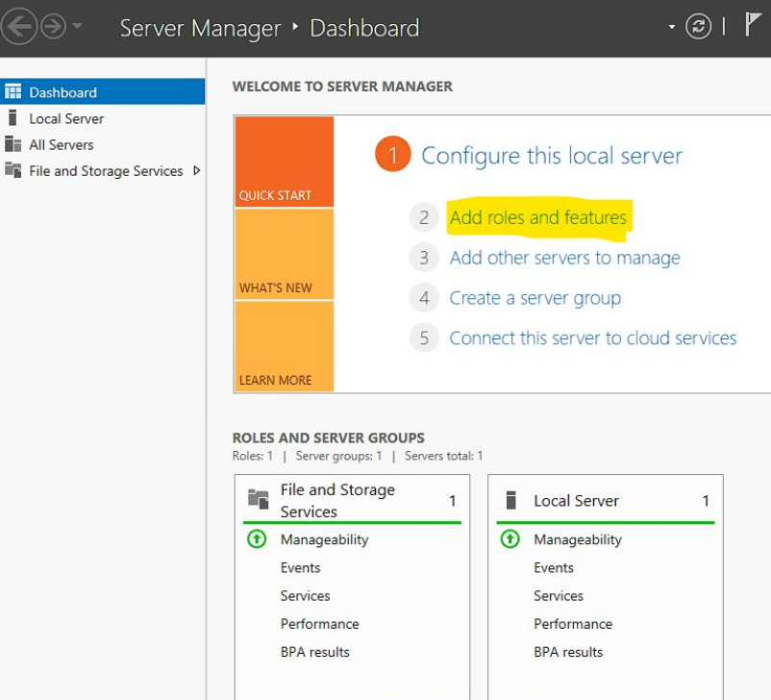

- Installed Web Server IIS role by clicking on service manager – add roles & features – click on service roles tab – click on add features – Then click on install

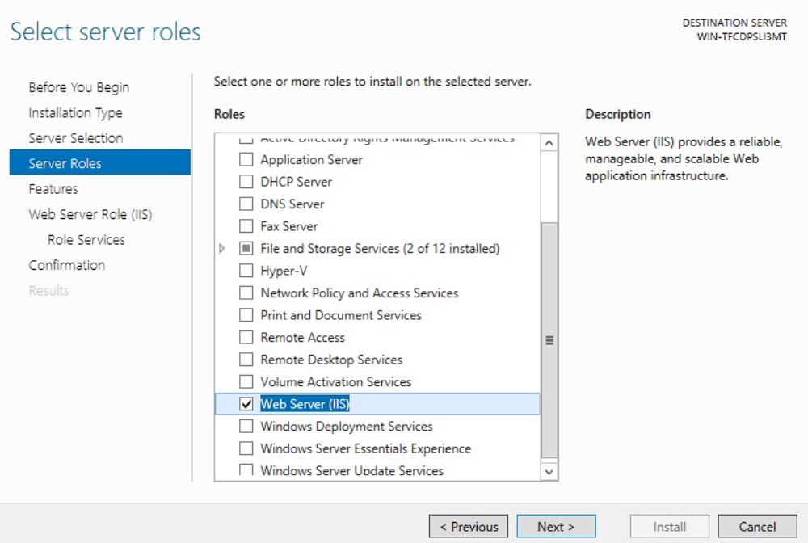

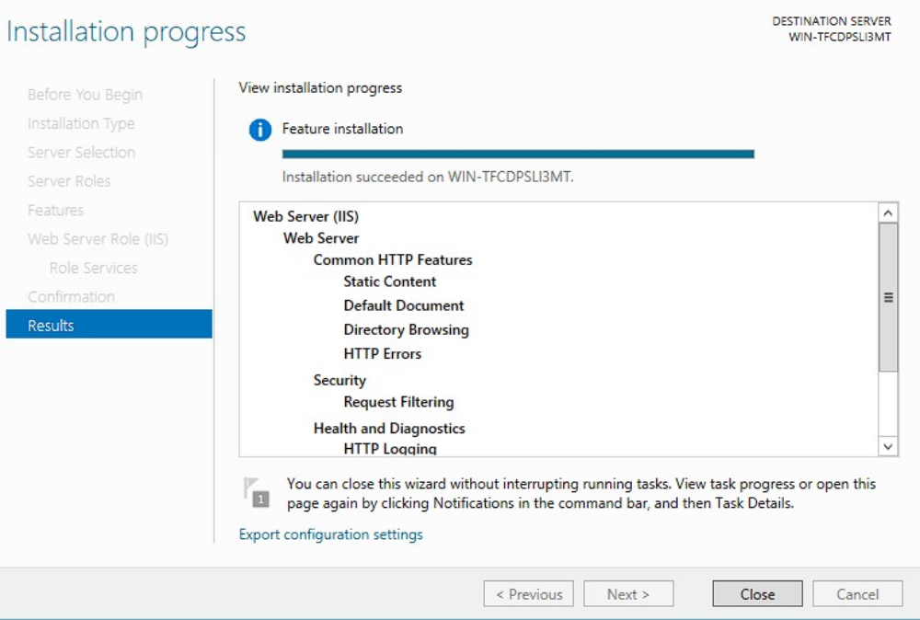
- Opened C drive in webserver went to inetpub/wwwroot deleted two files.
- Created a new text file and wrote a basic Html script and later saved it as index.html
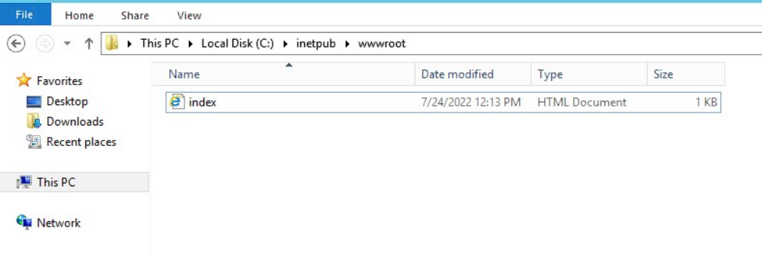
- Taken the Public IP address of the server and pasted it on the browser to check whether the server is connected or not.

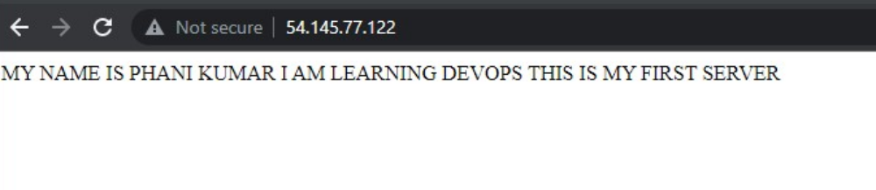
- Successfully connected to the IIS Webserver.

